**Background and Problem Statement**

After exploring availabe data which incorporate information of 276 similar resorts in 35 states across U.S., Big Mountain Resort demonstrates its high quality of facilities and service in term of distributing facilities, vertical drop, snow making area and no. of runs etc. In addition, after comparison with other resorts, Big Mountain Resort’s ticket price is relatively expensive in U.S. and the most expenive in Monotona.

After installing an additional chair lift which increases operating costs by $1,540,000 per season, the resorts realised one problem that the resot has no good sense of how important some facilities are compared to others and they do not sure how will customers value different facilities. This problem may lead to consequences that the resort can not stragtgily set up their ticket price and adjustment on facilities. The resort may under/overcharge customers and open up expensive unpopular facilities. In other word, the resort is not capitalizing on its facilities as much as it could and may lose great profit because of this.

**Model and Findings**

In view of the situation, a model has been created based on information of 276 similar resorts in U.S.. One of the most important findings is the importance of different attributes (faciliies) of resort toward ticket price. The results are as follow:

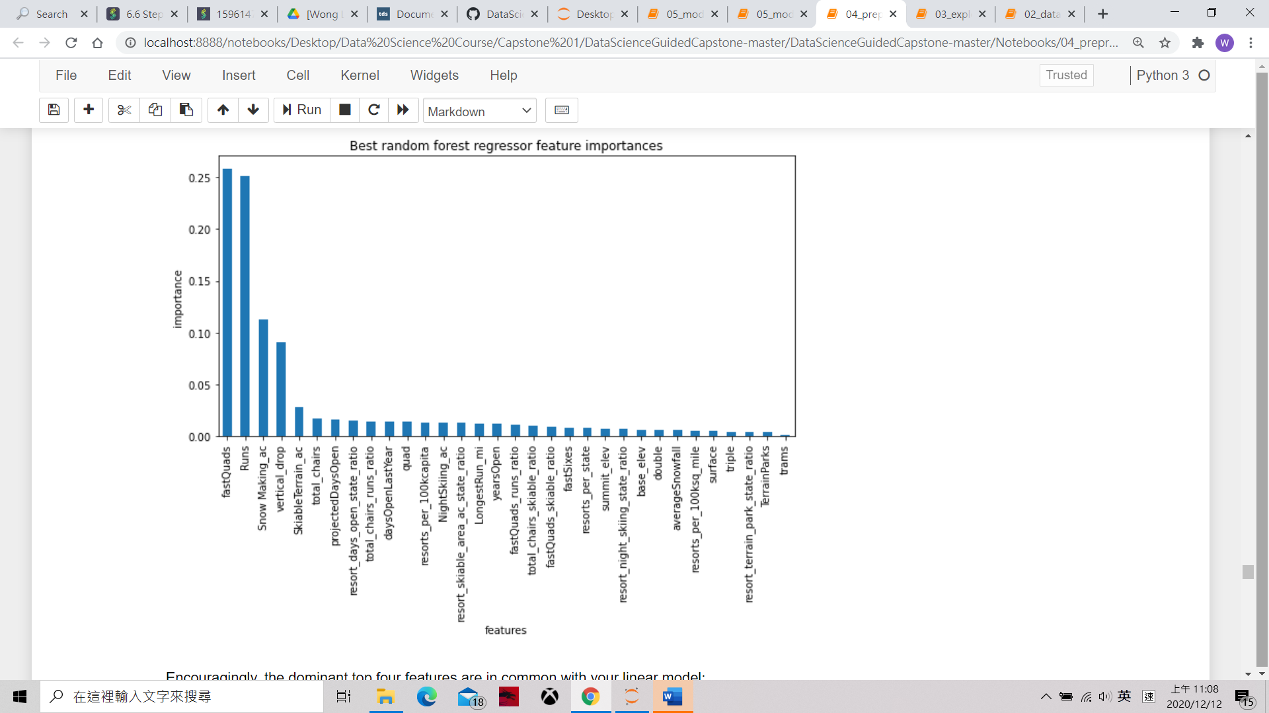

Figure 1 Importance of different attributes (faciliies) of resort toward ticket price

It is important to highlight that the model assumes other resorts are largely setting prices based on how much people value certain facilities. Based on Fig 1, no. of fastquads, no. of runs, snow making area and vertical drop are the four most crucial attributes which covered more than 95% importance. The resorts can focus on these four attributes to adjust opening of facilities.

Second, the model predicts the ticket price of the resort shall be $95.87 which is much higher than current $81 ticket price. This indicates that the resort is underchaging compared with its current facilities and service. Moreover, stuffs can always change the no. of facilities in the resort and input the change into the model. The model will predice new tick price based on our input. This provides a powerful tool if the resort want to try different combination of facilities and predict the ticket price in certains scanerios.

**Recommendation and Further Studies**

Based on the findings, it is recommended that the resort can point out the most unpopular runs and their related facilities. Then the resort can try work out different combination of facilities to be closed and predict the ticket price by the model. Finally, by calculating the cut of operational cost and increase in ticket revenue, we can choose the optimal combination. (The study assumes 35000 customers per season and each customer will stay 5 days in the hotal for revenue calculation)

Moreover, when testing how will the closure of runs will affect the ticket price, some patterns have be discovered:

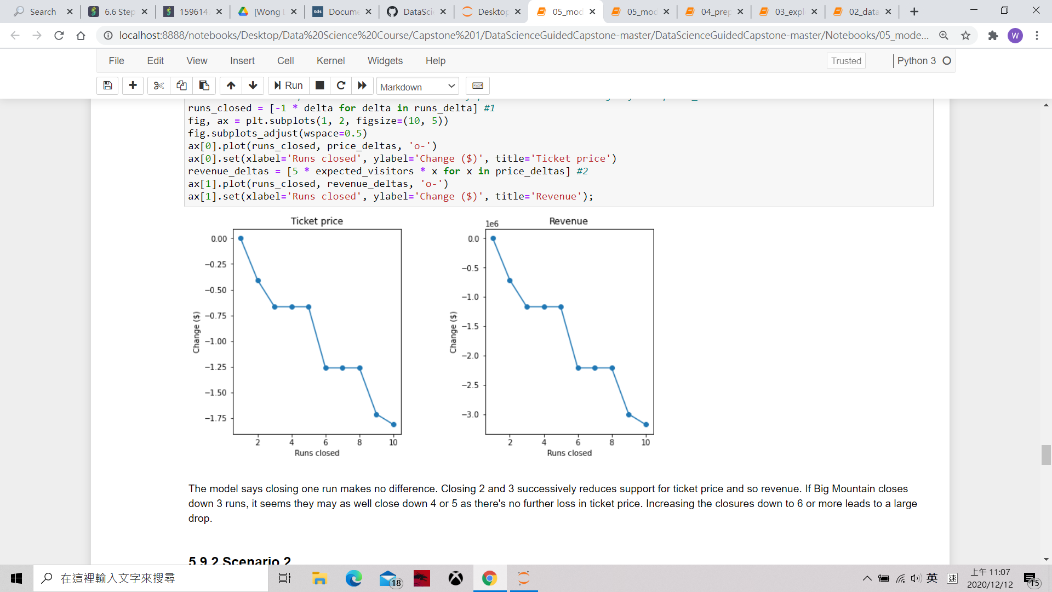

Figure 2 Closure of runs against change in ticket price and revenue

In figure 2, it can be observed that the closure of facilities is not always linear proportional to the drop of ticket price. In the sense of maximizing profit, the resorts will definitely close 5 or 8 runs rather than close 3 or 6 runs because the predicted ticket price for closing 3-5 or 6-8 runs are the same respectively. Further similar studies can be carried out and spread to all important attributes so that better trade off between closure of facility and cut down of operating cost can be drawn.

Last but not least, in order to work out more complete solution, the operational costs of other existing facilities are important for calculating the cut of cost. In addition, it is reasonable that if the price and facilities are adjusted in the resort, the no. of customers in the coming season will be affected accordingly. In view of this, there is a need to build up another model to predict the no. of customers and the average day each customer stay when we are changing the resorts facilities and ticket price. This new model will require another set of data such as no. of customers and the no. of days each customer stay in different resorts